RAP- Emax -13.05.2027- Day27-

Eml-ENtity and create by association
3:00
In previous session we created : root entity: ZR_TRAV_HDR and alias is trav_hdr
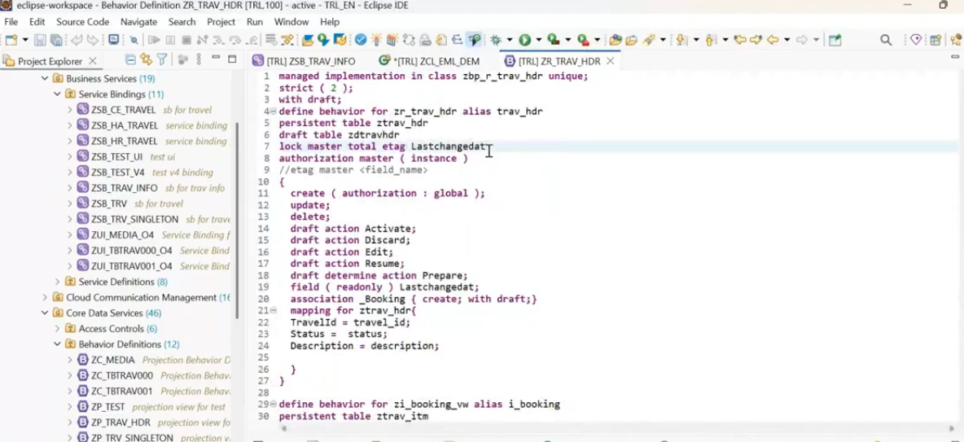need to understand the alias name. when we have the multiple entities, How you can segregate and how you can differentiate, what entity you are reading ..? Now i want to read multiple entity but how come you are segregating . when you want to read entity should root entity. it should not be normal root enity.

EML part: firstly able to discuss read by association.
How you can read our associated entity data along which your parent entity data
Previously we created this class : ZCL_EML_DEM.
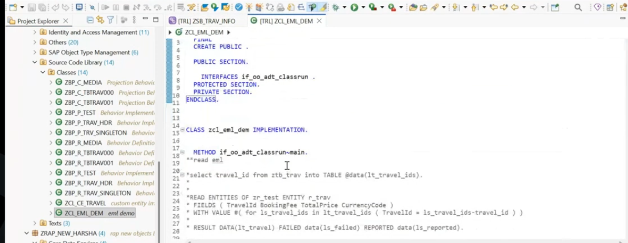
First read the travel header data and read the association entity data.
I want to read the association data for this travel header data travel id to i want get the booking data for this..
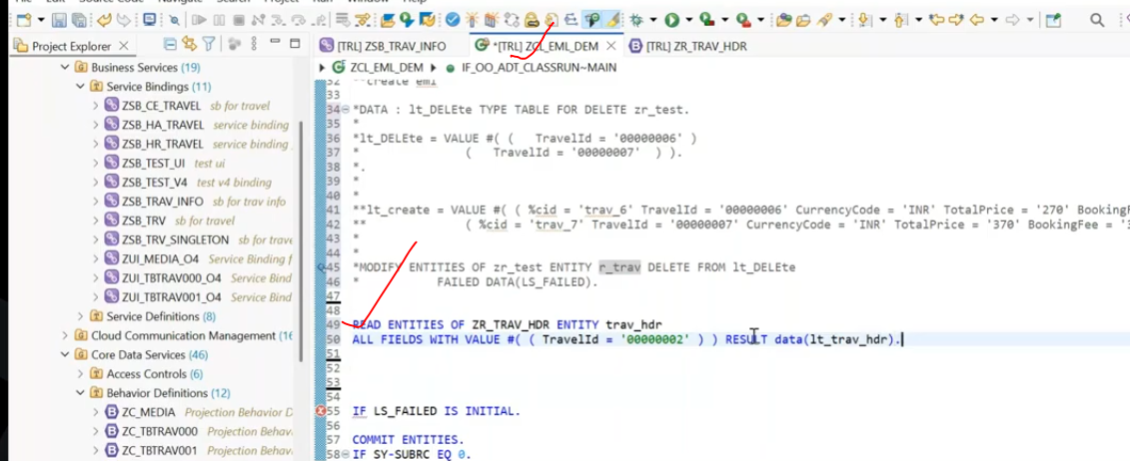
from this assocaition, you want to read the selected fields, do you want to read with selected all fields.
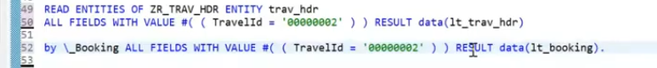
in this we have a draw back..
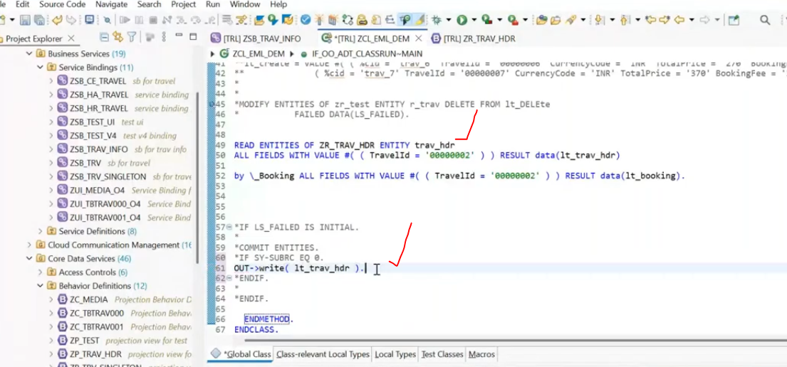
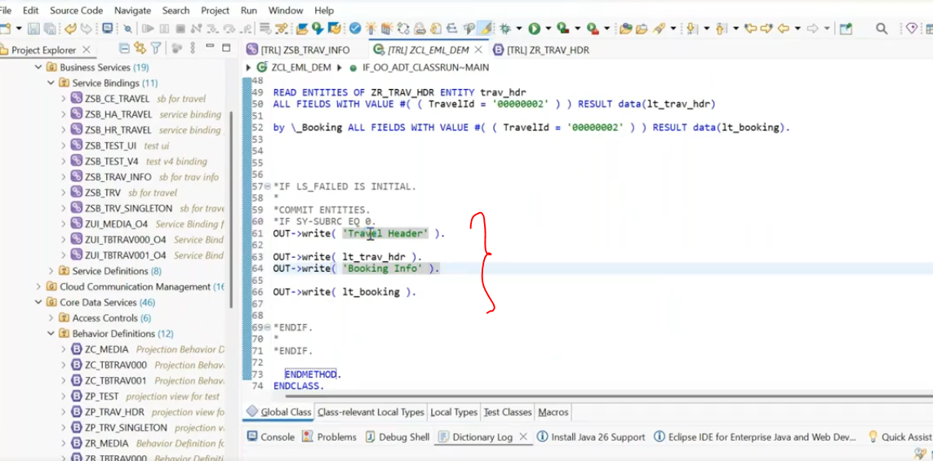
save and activate.
Execute - F9- you will able to see the output.
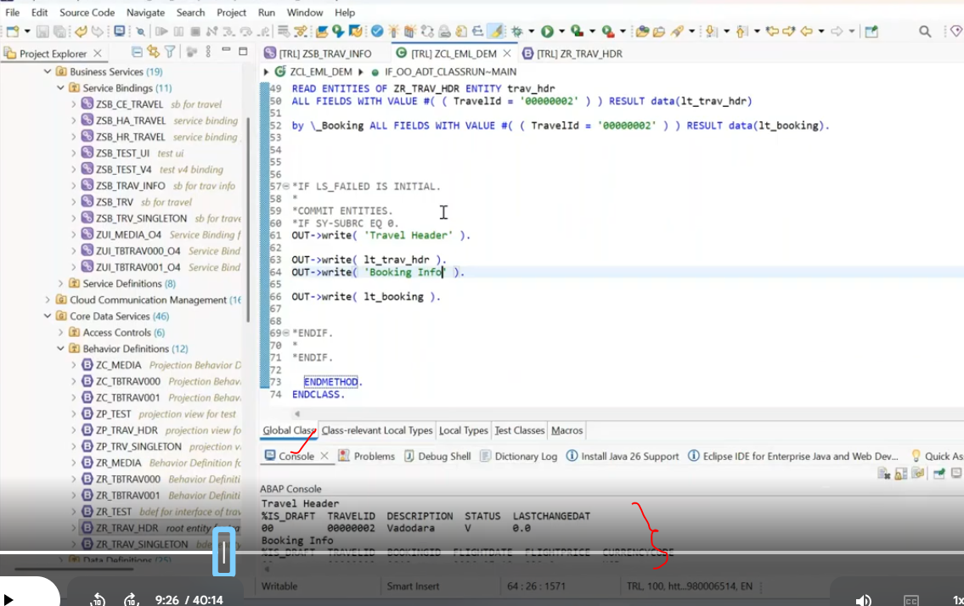
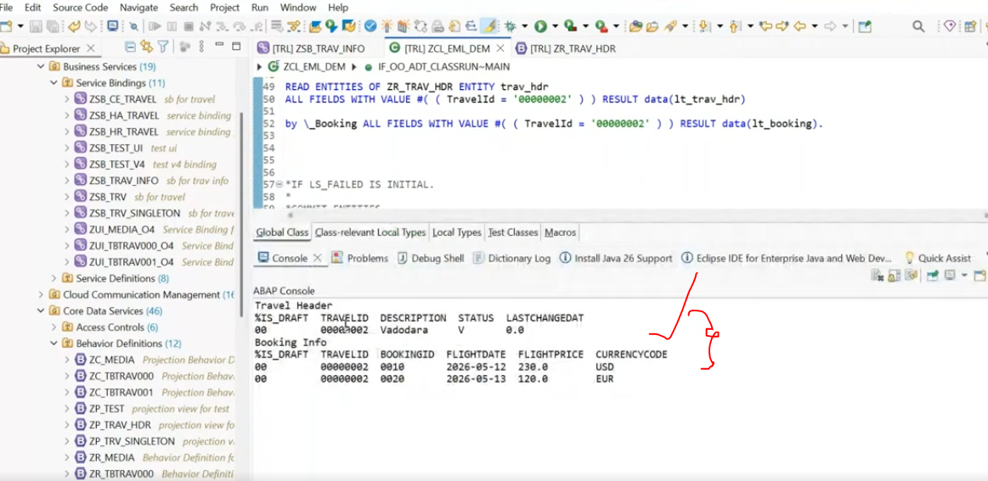
in this we have a draw back. here it is retrieving all the items , but i want to retrieve the selected item only.. means particular item i want to retrieve based on booking id ...
use the ctrl + space bar. --> you will get all the properties.
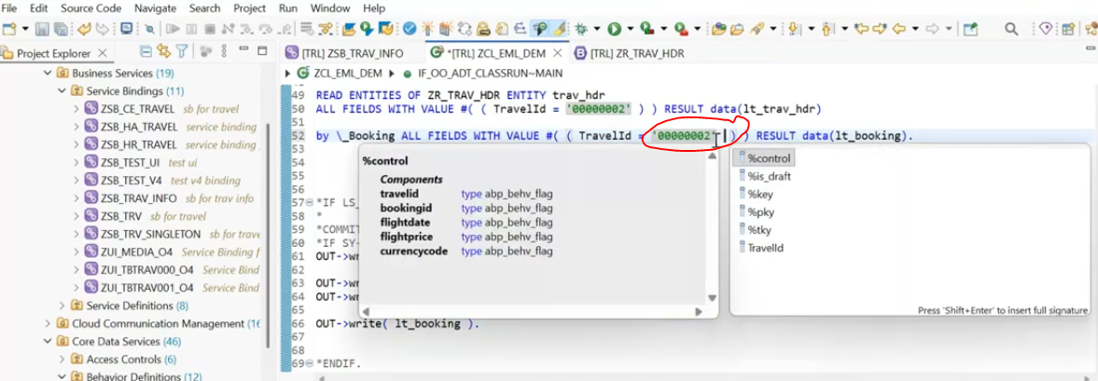
11:00
here only travel id is available. but booking id is not available here..
but when you want to return all the associated entity data for that header, use this eml ( for all items on corresponding header ) but particularly when you want to return the selected item this type of an eml is not recommendable and will not be use.
in this time what can i do? - so here another kind of eml called as entity with read entities.
entity <alias name> all fields with value #((travelid = '00000002' bookingid = '000010')) result data(lt_booking).
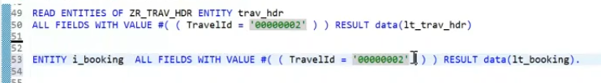
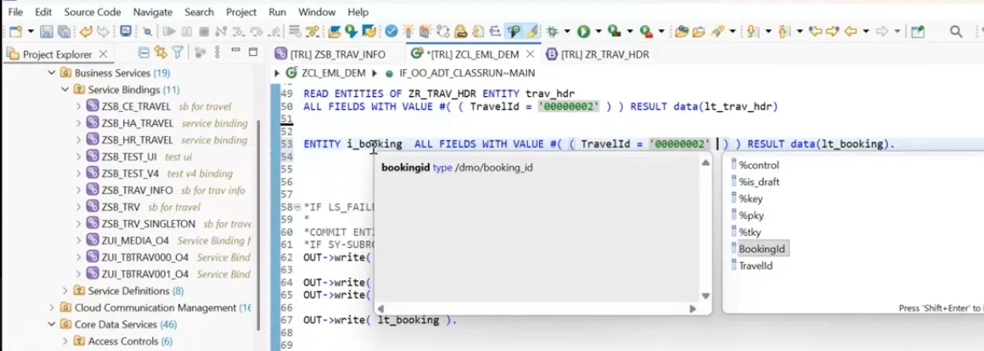
now received the booking id - because we specifies the entity.- now use the bookingid in where condition of entity.
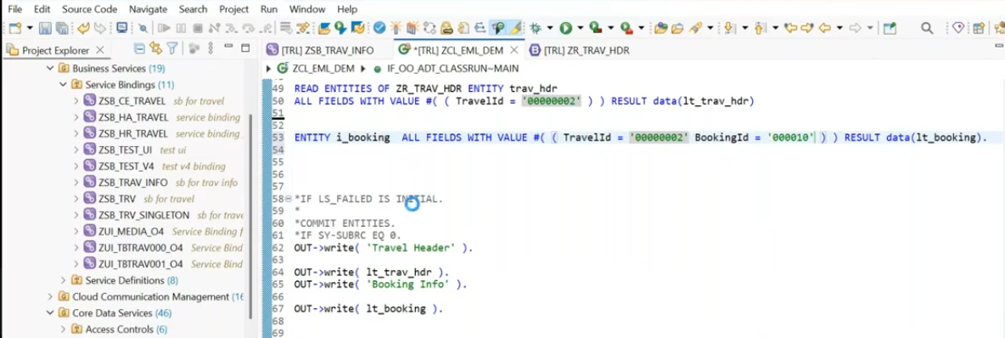
save and activate. execute.
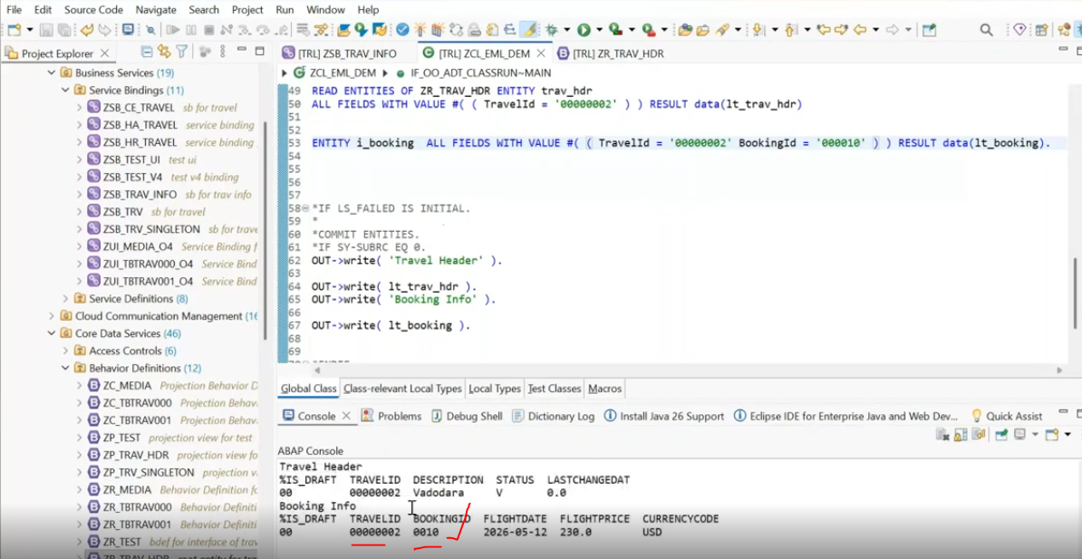
Here now able to get the specific booking id related data received.

Create By assocaition- Eml:
How you can create header entity data along with child entity data. in a single go?
create header table : lt_trav_hdr type table for create zr_Trav_hdr.
create item: lt_booking type table for create zr_Trv_hdr\_booking.
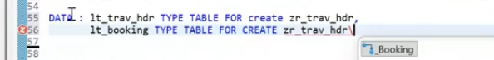
put the cursor in lt_booking --> press f2 you will get the structure information for line item.
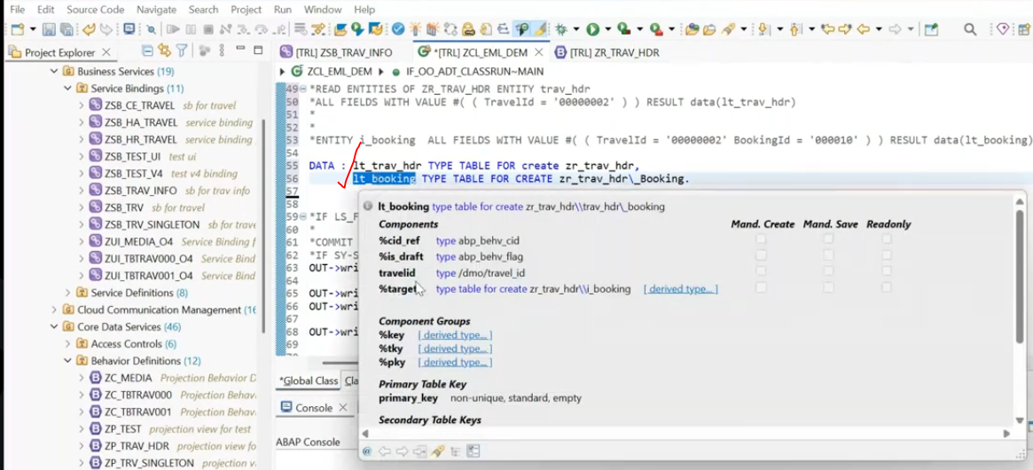
here %target - new added parameter when you declare with the association(_booking).
What you expect from internal table, ? we expect an booking entity fields--> chile entity fields are available in the %target. now we want to see the what all are fields re available for %target, click on derived type.
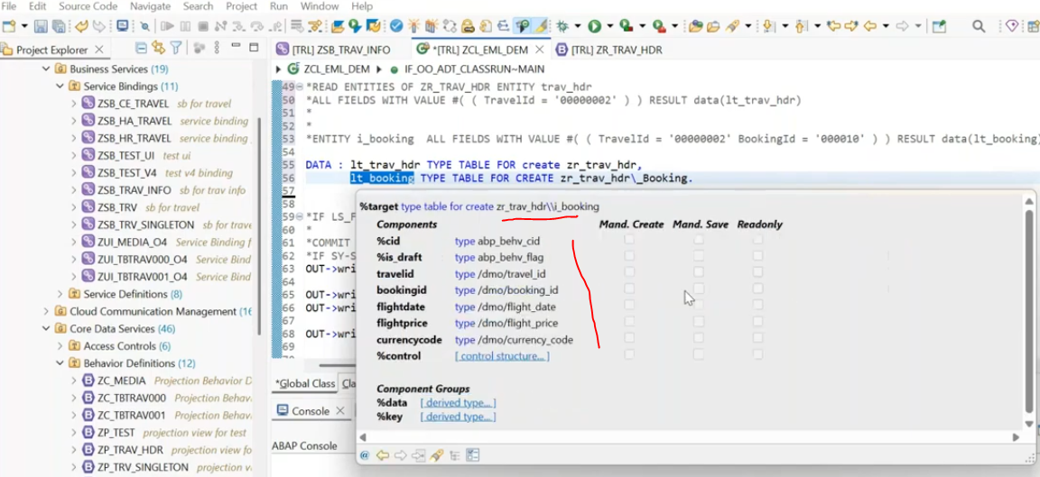
But directly, i can't use the %target. - this is in deep structure.
so we need to declare the work area to populate the %target.
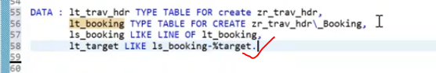
Now fill the internal tables.
first fill the header data and item data with %control structure -( %control-- Which fields of data update in table)
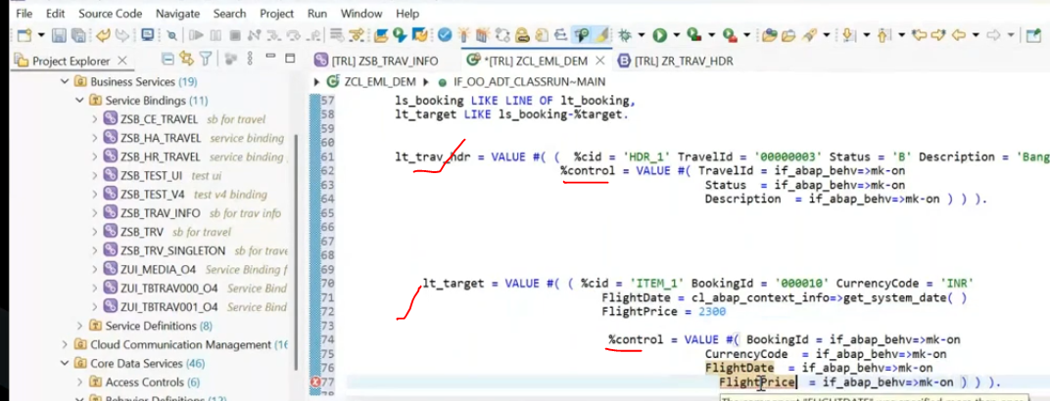
We filled the separate header and line item data.
Now we have to connect the header and item.- in item table we have the %cidref field is available means-- what ever header %cid is there, you have to pass those to the item %cid_Ref field. from that it will capture the header/parent the data.
linking header and item table:
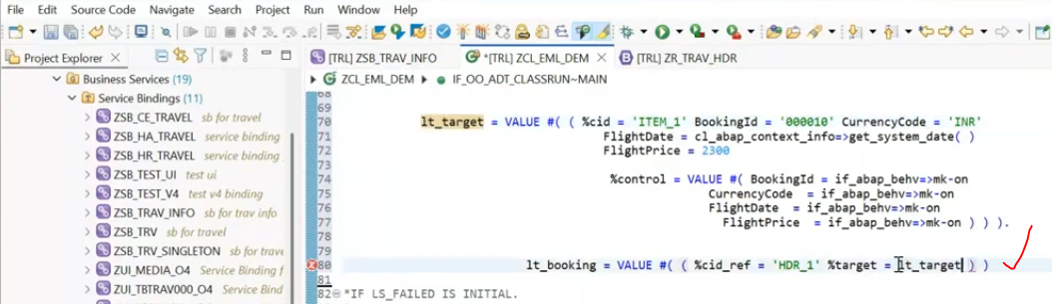
Now all the data populated to header and item table and linking also done between the header and item.
Now update the data to the db tables using modify entities:
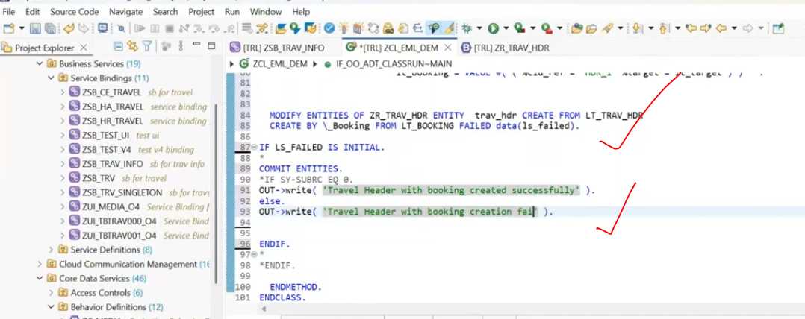
save and activate
Execute
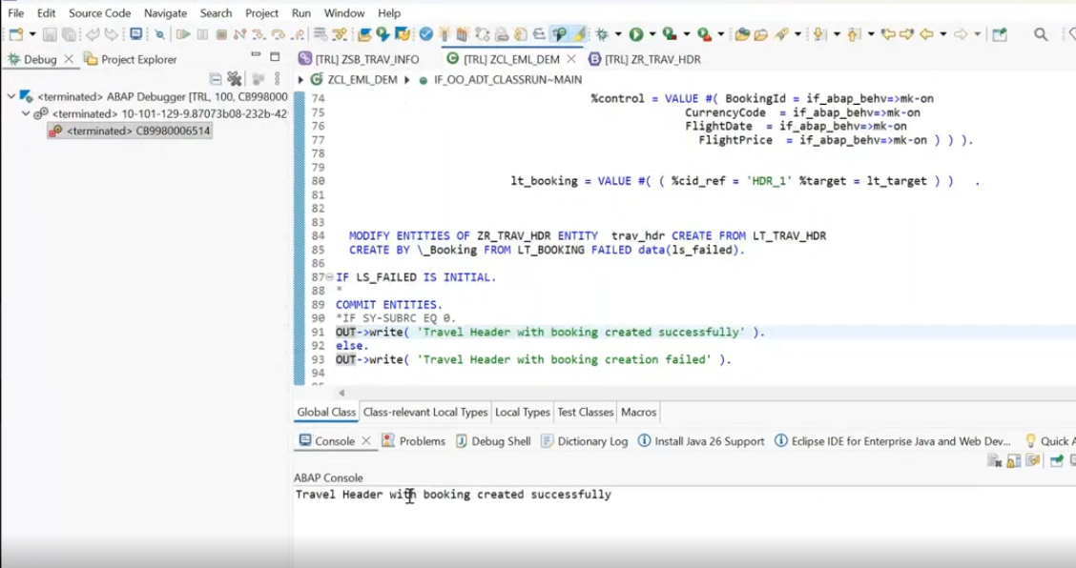Now check the existing fiori elements app coming or not...
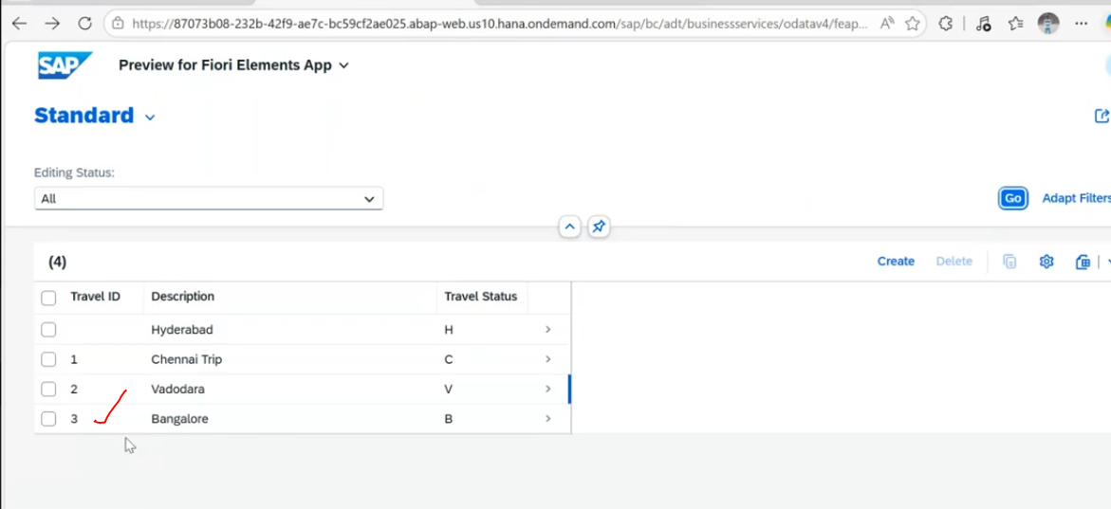
Header appears and check the object page for line item/ booking data.
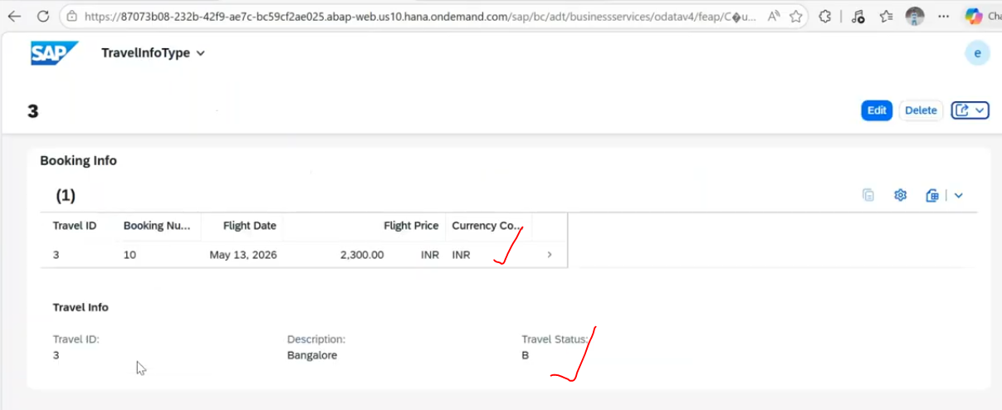
36:00
Query: How to delete the data using modify entities.?
Query : How to check the foreign key validation in rap?- not required any validation, for single table when you use the repository object.. RAP frame work will take care?
Query: CDS view, can we consume it badi? not possible - but use the define view .
Cloud/Developer Extensibility: If you are working in SAP S/4HANA Public Cloud or using In-App BAdIs with Developer Extensibility, ensure the CDS view is released for C1 (Use System-Internally) or C2 (Use for Key User Extensibility)
Extend :
https://help.sap.com/docs/SAP_NETWEAVER_750/cc0c305d2fab47bd808adcad3ca7ee9d/dd02965db1c6417a8a2015288fa0bb8b.html?version=7.5.12

